Sustainable Airline Reservation Systems: Environmental Impact Analysis

Date : 16-02-2025
Prepared by : Sakib Mansuri

1. Introduction
This study analyzes a comprehensive dataset of over 286,000 airline flights to evaluate the environmental impact of current airline reservation systems and identify opportunities for improving sustainability. Our analysis focused on key metrics such as CO2 emissions, fuel efficiency, and load factors across different aircraft classes and routes.

2. Key Findings and Analysis

2.1 Aircraft Class Efficiency
Our analysis revealed significant differences in efficiency across aircraft classes:
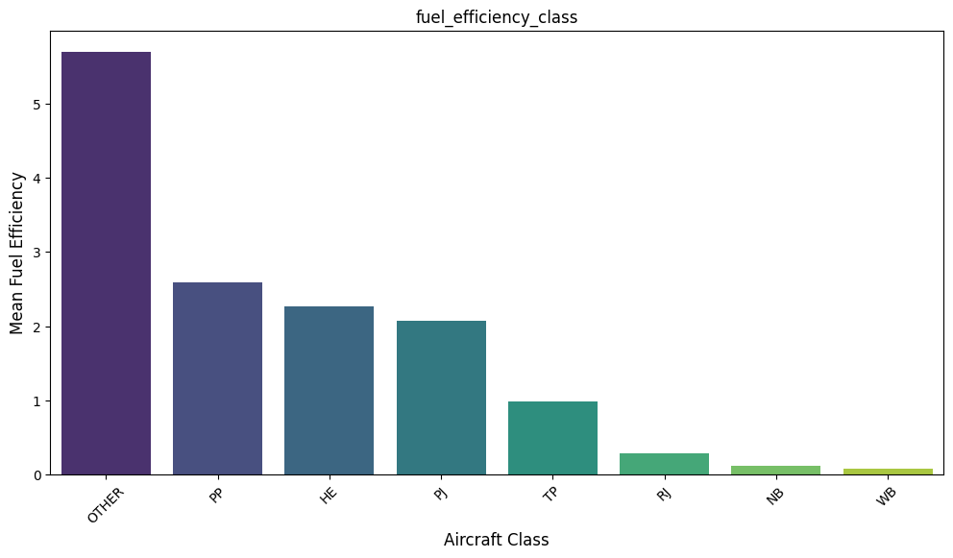
- Piston Propeller (PP) aircraft showed the highest fuel efficiency, followed by HE(helicopters) type aircraft.
- Wide-body (WB) and Private Jets (PJ) aircraft demonstrated moderate efficiency.
- Regional Jets (RJ) and Narrow-body (NB) were the least fuel-efficient.

This finding relates directly to the assignment topic "Comprehensive evaluation of the carbon footprint of current airline reservation systems and their environmental implications." It suggests that prioritizing more efficient aircraft classes in reservations could significantly reduce emissions.

2.2 CO2 Emission Intensity

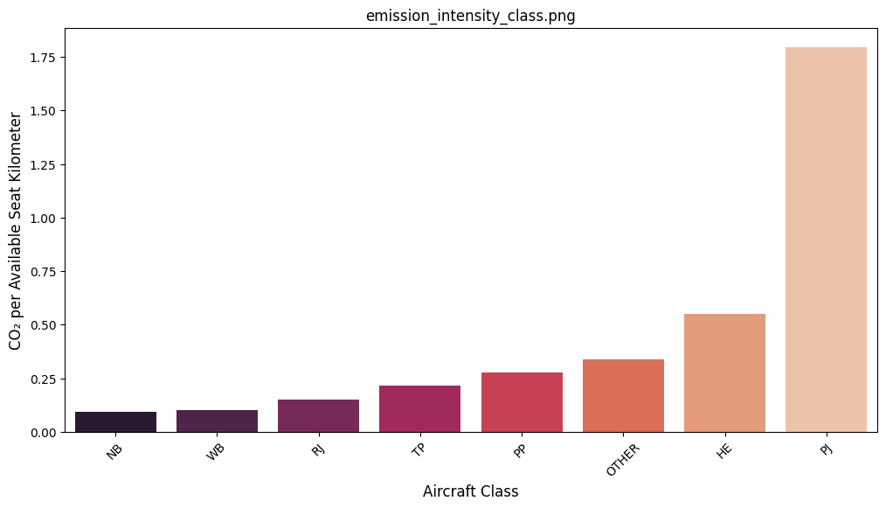

The CO2 emissions per Available Seat Kilometer (ASK) varied significantly across aircraft classes:
- Helicopters (HE) and Private Jets (PJ) showed the highest emission intensity.
- Wide-body (WB) and Narrow-body (NB) aircraft demonstrated the lowest emission intensity.
- Regional Jets (RJ) and Turbo Propeller (TP) , PP AND OTHER category aircraft fell in the middle range.

This insight addresses the topic "Investigate the environmental effects of airline reservation systems in relation to their energy use and emissions." It indicates that reservation systems should prioritize aircraft with lower emission intensities for optimal environmental performance.

2.3 Route Distance and Emissions

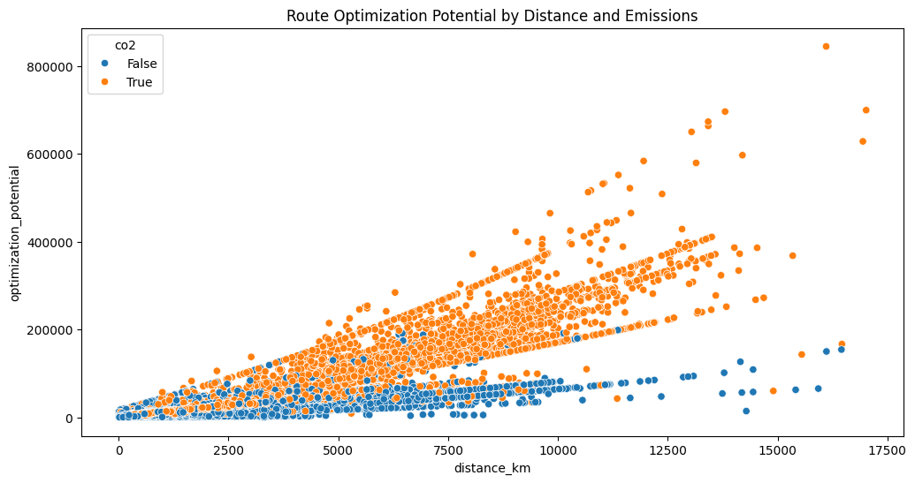

We observed a clear relationship between flight distance and emissions:

- Short-haul flights (<500 km) showed disproportionately high emissions potential.
- Long-haul flights (>1000 km) generally demonstrated lower emissions per kilometers.
- Several high-emission routes (highlighted in orange) present significant optimization opportunities.

This finding suggests that reservation systems should consider route optimization to minimize short-haul flights where possible and consolidate routes with high emission potentials.

Also , Long-distance flight can be optimized where giving the pessengers a stop at middle point and use another emission friendly aircraft classes can be more helpful and reduce carbon emission.

2.4 Load Factor Impact

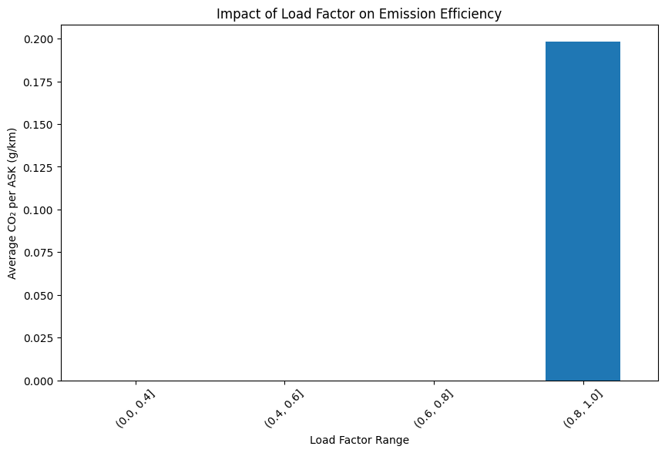

Load factor (percentage of seats filled) had a significant impact on efficiency:

- Emission efficiency improved dramatically as load factors increased, with the best performance at 80-100% capacity.

This finding relates to "Comprehensive analysis of resource consumption associated with existing airline reservation systems and its impact on sustainability." It suggests that reservation systems should prioritize filling flights to capacity to maximize efficiency.

3. Machine Learning Insights

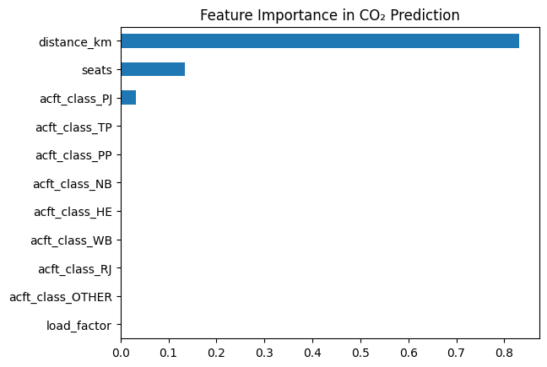

Our Random Forest model for predicting CO2 emissions achieved an RMSE of 1.56, indicating good predictive power. The most important features for predicting emissions were:

1. Distance
2. Aircraft class (particularly WB and NB)
3. Number of seats
4. Load factor

This model could be integrated into reservation systems to provide real-time emissions estimates and guide booking decisions.

4. Strategies and Recommendations
1. Aircraft Class Optimization: Develop algorithms to prioritize booking passengers on more efficient aircraft classes (WB, NB, TP) when multiple options are available.
2. Route Consolidation: Implement systems to combine multiple short-haul flights into single long-haul flights where feasible, potentially using larger, more efficient aircraft.
3. Dynamic Pricing for Load Factor Optimization: Introduce pricing mechanisms that incentivize bookings on underutilized flights to improve overall load factors.
4. Emissions Transparency: Integrate CO2 emissions data into the booking interface to allow environmentally-conscious consumers to make informed choices.

5. Flaws in Current Systems
1. Lack of Emissions Consideration: Current systems often prioritize factors like price and schedule over environmental impact.
2. Inefficient Short-Haul Operations: The high number of short-haul flights with poor efficiency suggests a lack of route optimization.
3. Underutilization of Efficient Aircraft: The significant efficiency gap between aircraft classes indicates that more could be done to prioritize efficient aircraft usage.

6. Conclusion

By implementing these strategies and addressing the identified flaws, airline reservation systems can play a crucial role in reducing the aviation industry's carbon footprint. The data-driven insights from this analysis provide a strong foundation for developing sustainable software solutions that balance operational needs with environmental responsibility.
To fully realize these benefits, reservation systems will need to incorporate real-time emissions data, predictive modeling, and dynamic optimization algorithms. Future research should focus on developing and testing these advanced features to create truly sustainable airline reservation platforms.

Citations:
https://data.niaid.nih.gov/resources?id=zenodo_10125898
https://aeroscope.isae-supaero.fr/
https://zenodo.org/records/10143773
https://journals.open.tudelft.nl/joas/issue/view/984
https://www.kaggle.com/datasets/decentnoman/airline-reservation-system
Salgas, A., Sun, J., Delbecq, S., Planès, T., & Lafforgue, G. (2023). Compilation of an open-source traffic and CO2 emissions dataset for commercial aviation. Journal of Open Aviation Science. https://doi.org/10.59490/joas.2023.7201

